Manual de utilização do CMIS Content Manager 8.4.3 (JAVA CMIS)

Versão 1.0
Data de criação: 14/05/2012

Índice

1 Objetivos 3
2 Pré-requisitos 4
2.1 Preparação estação de desenvolvimento 4
3 Procedimentos 7
3.1 Referências Eclipse ou Rational Application Developer 7
4 Exemplo de utilização 7
4.1 Importar os Jars 7
4.2 Download de Documento do Content Manager 8
4.3 Inclusão de Documento no Content 9
4.4 Inclusão de Pasta no Content 11
4.5 Execução de Query de Documentos no Content 14
5 Referências 15

Objetivos
Explicar o procedimento de acesso e operações básicas ao Content Manager 8.4.3 via padrão CMIS (IBM Content Management Interoperability Services for Content Manager Version 1.0).

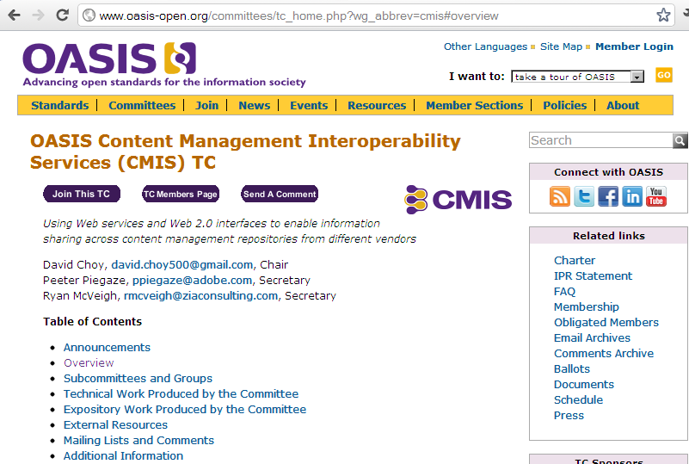
http://www.oasis-open.org/committees/tc_home.php?wg_abbrev=cmis#overview

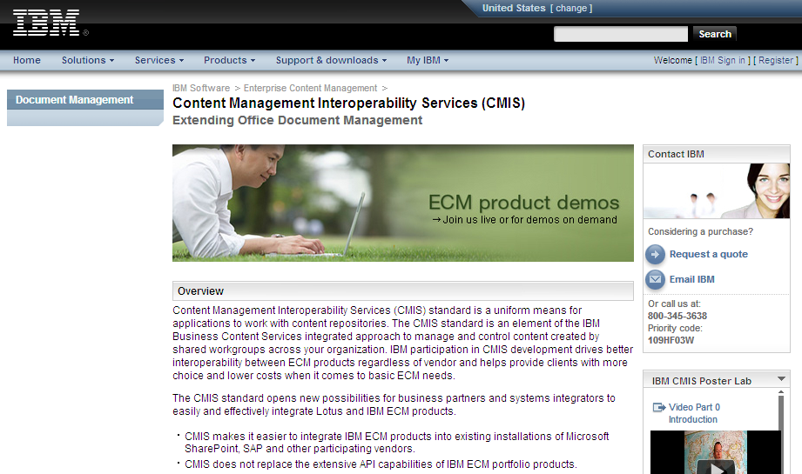
http://www-01.ibm.com/software/data/content-management/cm-interoperablity-services.html

Pré-requisitos

Preparação estação de desenvolvimento

2.1.1 Eclipse ou Rational Application Developer

Os testes foram realizados com as IDEs Eclipse e Rational Application Developer.
Utilizar Java 5 para compilar os códigos de acesso ao CM-CMIS.

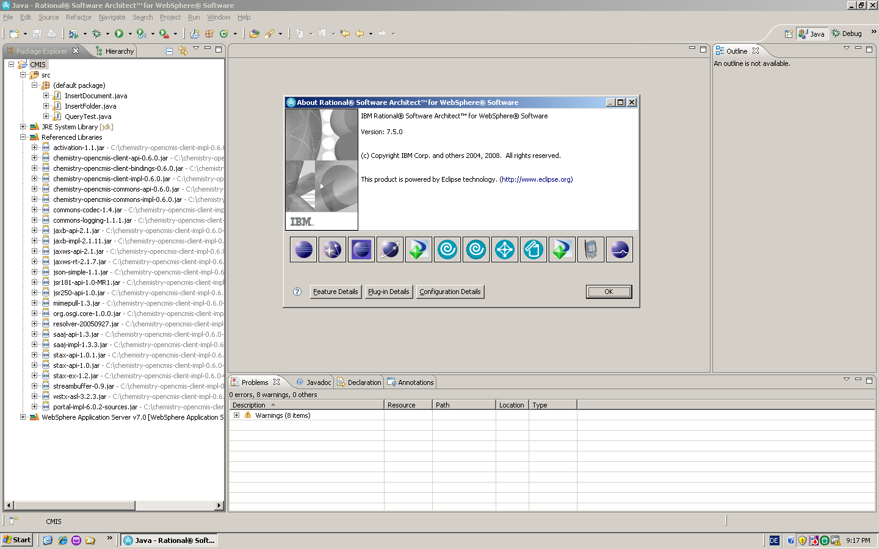

2.1.2 Biblioteca Apache Chemistry OpenCMIS

Solicitar as bibliotecas necessárias para utilização do CMIS à equipe AdminECM.

Segue abaixo a relação de .jar necessários:

activation-1.1.jar
chemistry-opencmis-client-api-0.6.0.jar
chemistry-opencmis-client-bindings-0.6.0.jar
chemistry-opencmis-client-impl-0.6.0-with-dependencies.zip
chemistry-opencmis-client-impl-0.6.0.jar
chemistry-opencmis-commons-api-0.6.0.jar
chemistry-opencmis-commons-impl-0.6.0.jar
commons-codec-1.4.jar
commons-logging-1.1.1.jar
jaxb-api-2.1.jar
jaxb-impl-2.1.11.jar
jaxws-api-2.1.jar
jaxws-rt-2.1.7.jar
json-simple-1.1.jar
jsr181-api-1.0-MR1.jar
jsr250-api-1.0.jar
mimepull-1.3.jar
org.osgi.core-1.0.0.jar
portal-impl-6.0.2-sources.jar
resolver-20050927.jar
saaj-api-1.3.jar
saaj-impl-1.3.3.jar
stax-api-1.0.1.jar
stax-api-1.0.jar
stax-ex-1.2.jar
streambuffer-0.9.jar
wstx-asl-3.2.3.jar

2.1.3 Endereços Repositório CMIS

Segue abaixo tabela com os respectivos endereços de acesso ao IBM CM-CMIS.

Item | Valor Exemplo
ID do Repositório | $x!lscmdes (desenvolvimento)  $x!nlsdb01 (produção)
RESTful AtomPub binding service document | http://scxx072cto:9083/cmcmis/resources/Service (desenvolvimento)  http://scxx072cto:9084/cmcmis/resources/Service (produção)
Credenciais para acesso ao repositório | Usuário e senha configurados para acesso no Content Manager

Procedimentos

3.1 Referências Eclipse ou Rational Application Developer
Incluir as bibliotecas do projeto OpenCMIS fornecidas pela equipe AdminECM.

Para todos os testes o itemtype possuía a seguinte configuração:
itemType:
OA0_ExemploCM

campos:
OA0_Usuario( varchar )
OA0_NumDoc (inteiro)
AO0_Titulo (varchar)
OA0_DtCriacao (timestamp)

4 Exemplo de utilização

4.1 Importar os Jars

Importar todos os Jars para o projeto.

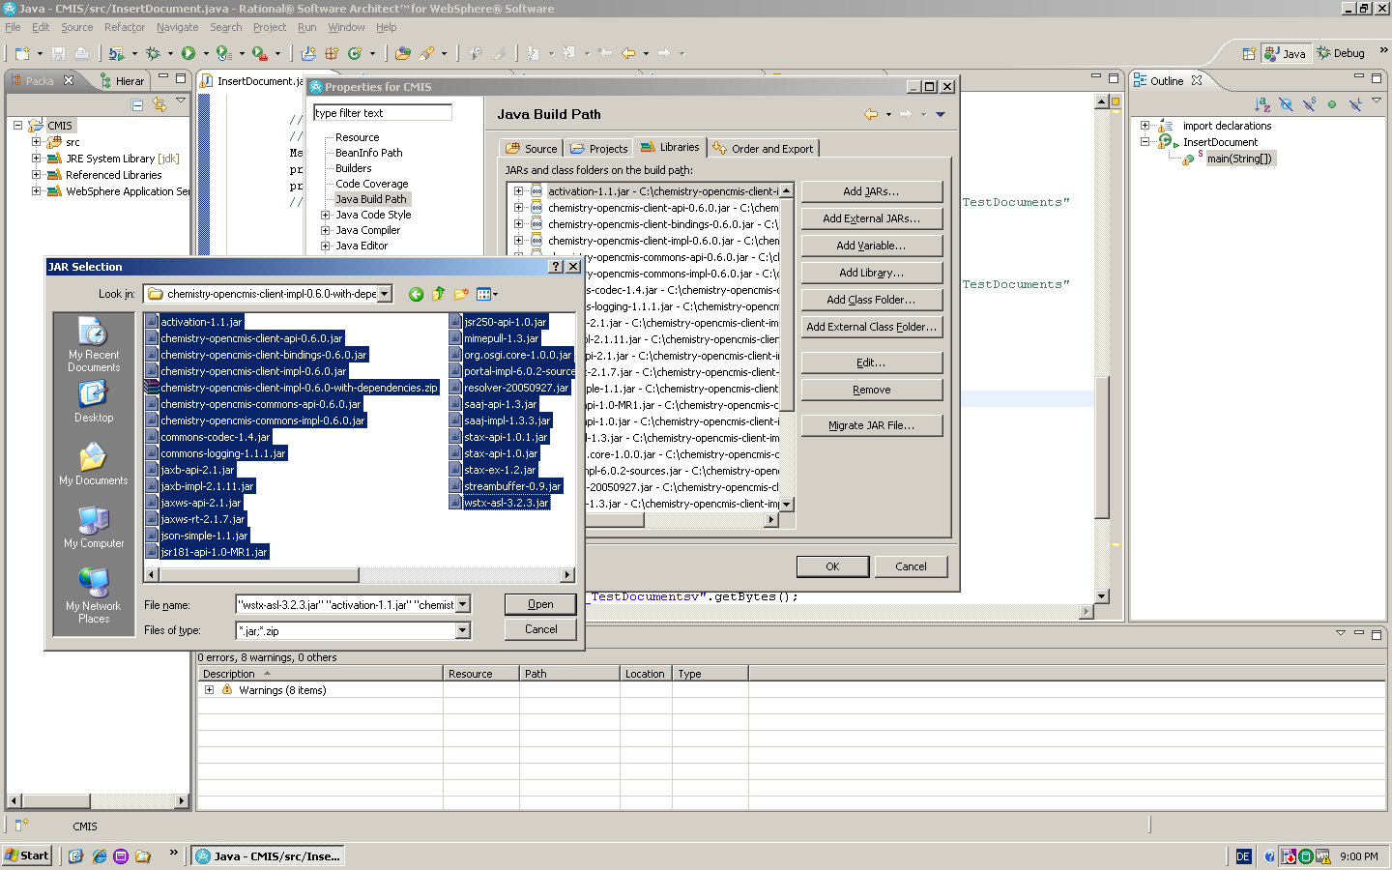

4.2 Download de Documento do Content Manager

Segue código exemplo para download de documentos

import java.io.File;
import java.io.FileOutputStream;
import java.io.InputStream;
import java.util.HashMap;
import java.util.Map;

import org.apache.chemistry.opencmis.client.api.Document;
import org.apache.chemistry.opencmis.client.api.ItemIterable;
import org.apache.chemistry.opencmis.client.api.QueryResult;
import org.apache.chemistry.opencmis.client.api.Session;
import org.apache.chemistry.opencmis.client.api.SessionFactory;
import org.apache.chemistry.opencmis.client.runtime.SessionFactoryImpl;
import org.apache.chemistry.opencmis.commons.PropertyIds;
import org.apache.chemistry.opencmis.commons.SessionParameter;
import org.apache.chemistry.opencmis.commons.enums.BindingType;

public class QueryTest {
// ajustar o endpoint de conexao
private static final String CMIS_ENDPOINT_TEST_SERVER = "http://scxx072cto:9083/cmcmis/resources/Service";

public static void main(String args[]) {

// default factory implementation
SessionFactory factory = SessionFactoryImpl.newInstance();
Map<String, String> parameters = new HashMap<String, String>();
// colocar usuario e senha configurado no content manager
parameters.put(SessionParameter.USER, "user");
parameters.put(SessionParameter.PASSWORD, "senha");
// connection settings
parameters.put(SessionParameter.ATOMPUB_URL, CMIS_ENDPOINT_TEST_SERVER);
parameters.put(SessionParameter.BINDING_TYPE, BindingType.ATOMPUB
.value());
// create session
Session session = factory.getRepositories(parameters).get(0).createSession();

String id = "";
ItemIterable<QueryResult> results = session.query(
//formar a query de consulta no content manager
"SELECT * FROM OA0_ExemploCM where OA0_Usuario='MONITOR'", false);
for (QueryResult result : results) {
id = result.getPropertyValueById(PropertyIds.OBJECT_ID);
System.out.println(id);

}

Document doc = (Document) session.getObject(session.createObjectId(id));

String fileName = doc.getName();

InputStream stream = doc.getContentStream().getStream();
//gravar o documento no filesystem
File fileOutput = new File("C:/PROGRAMAS/CMIS_IBM/fileOutput.txt");

FileOutputStream fos = null;

try{

fos = new FileOutputStream(fileOutput);
byte[] buffer = new byte[2048];
int nLidos;
while ((nLidos = stream.read(buffer)) >=0){
fos.write(buffer, 0 , nLidos);
}
fos.flush();

}
catch (Exception e) {
// TODO: handle exception
}

}

}

4.3 Inclusão de Documento no Content

Segue código exemplo para inclusão de documento no repositório.

import java.io.ByteArrayInputStream;
import java.io.InputStream;
import java.math.BigInteger;
import java.sql.Timestamp;
import java.text.SimpleDateFormat;
import java.util.ArrayList;
import java.util.Date;
import java.util.Dictionary;
import java.util.GregorianCalendar;
import java.util.HashMap;
import java.util.List;
import java.util.Map;

import org.apache.chemistry.opencmis.client.api.CmisObject;
import org.apache.chemistry.opencmis.client.api.Document;
import org.apache.chemistry.opencmis.client.api.Folder;
import org.apache.chemistry.opencmis.client.api.ItemIterable;
import org.apache.chemistry.opencmis.client.api.Repository;
import org.apache.chemistry.opencmis.client.api.Session;
import org.apache.chemistry.opencmis.client.api.SessionFactory;
import org.apache.chemistry.opencmis.client.runtime.SessionFactoryImpl;
import org.apache.chemistry.opencmis.commons.PropertyIds;
import org.apache.chemistry.opencmis.commons.SessionParameter;
import org.apache.chemistry.opencmis.commons.data.ContentStream;
import org.apache.chemistry.opencmis.commons.enums.BindingType;
import org.apache.chemistry.opencmis.commons.enums.VersioningState;
import org.apache.chemistry.opencmis.commons.impl.dataobjects.ContentStreamImpl;

//import com.ibm.ws.sib.wsn.webservices.utils.DateTimeUtils;

public class InsertDocument {

public static void main(String args[]) {

System.out.println("Getting Started...");
System.out.println("------------------");

// Create a SessionFactory and set up the SessionParameter map
SessionFactory sessionFactory = SessionFactoryImpl.newInstance();
Map<String, String> parameter = new HashMap<String, String>();

// user credentials - using the standard admin/admin
// colocar o usuario e senha
parameter.put(SessionParameter.USER, "user");
parameter.put(SessionParameter.PASSWORD, "senha");

// connection settings - we're connecting to a public cmis repo,
// using the AtomPUB binding, but there are other options here,
// or you can substitute your own URL
// passar a url de conexao
parameter.put(SessionParameter.ATOMPUB_URL,"http://scxx072cto:9083/cmcmis/resources/Service");

parameter.put(SessionParameter.BINDING_TYPE, BindingType.ATOMPUB
.value());

// find all the repositories at this URL - there should only be one.
List<Repository> repositories = new ArrayList<Repository>();
repositories = sessionFactory.getRepositories(parameter);
for (Repository r : repositories) {
System.out.println("Found repository: " + r.getName());
}

// create session with the first (and only) repository
Repository repository = repositories.get(0);
parameter.put(SessionParameter.REPOSITORY_ID, repository.getId());
Session session = sessionFactory.createSession(parameter);

System.out.println("Got a connection to repository: "
+ repository.getName() + ", with id: " + repository.getId());

// // An example of creating a session with a known repository id.
// parameter.put(SessionParameter.REPOSITORY_ID, "A1");
//Session session = sessionFactory.createSession(parameter);

// Get everything in the root folder and print the names of the objects
Folder root = session.getRootFolder();
ItemIterable<CmisObject> children = root.getChildren();
System.out.println("Found the following objects in the root folder:-");
/* for (CmisObject o : children) {
System.out.println(o.getName() + " which is of type "
+ o.getType().getDisplayName());
}
*/
System.out.println("\nFile and Folders...");
System.out.println("-------------------");

String name = "myNewDocument.txt";

// properties
// (minimal set: name and object type id)
Map<String, Object> properties = new HashMap<String, Object>();
properties.put(PropertyIds.OBJECT_TYPE_ID, "cmis:document");
properties.put(PropertyIds.NAME, name);
//properties.put(PropertyIds.OBJECT_TYPE_ID , "$t!-2_TestDocumentsv-1"); // item type "TestDocuments"

// definicao do ItemType

properties.put(PropertyIds.OBJECT_TYPE_ID , "$t!-2_OA0_ExemploCMv-1"); // item type "OA0_EXEMPLOCM"

GregorianCalendar time = new GregorianCalendar();

//Atributos do ItemType
properties.put("clbNonGroup.OA0_Usuario", "user");
properties.put("clbNonGroup.OA0_Titulo", "JAVA");
properties.put("clbNonGroup.OA0_NumDoc", 1);
properties.put("clbNonGroup.OA0_DtCriacao", time);

// content
//byte[] content = "Hello World! TESTE 2_TestDocumentsv".getBytes();
byte[] content = null;
try {
content = FileToBytes("C:\\RPC-01_arq1.pdf");
} catch (IOException e) {
// TODO Auto-generated catch block
e.printStackTrace();
}
InputStream stream = new ByteArrayInputStream(content);
ContentStream contentStream = new ContentStreamImpl(name, BigInteger
.valueOf(content.length), "application/pdf", stream);

// create a major version
Document newDoc = root.createDocument(properties,
contentStream, VersioningState.MAJOR);

}

public static byte[] FileToBytes(String inFile) throws IOException{
InputStream is = null;
byte[] buffer = null;
boolean success = true;
is = new FileInputStream(inFile);
buffer = new byte[is.available()];
is.read(buffer);
is.close();
return buffer;
}
}

4.4 Inclusão de Pasta no Content

Segue código exemplo para inclusão de pasta no repositório.

import java.io.ByteArrayInputStream;
import java.io.InputStream;
import java.math.BigInteger;
import java.sql.Timestamp;
import java.text.SimpleDateFormat;
import java.util.ArrayList;
import java.util.Calendar;
import java.util.GregorianCalendar;
import java.util.HashMap;
import java.util.List;
import java.util.Locale;
import java.util.Map;
import java.util.SimpleTimeZone;
import java.util.TimeZone;

import org.apache.chemistry.opencmis.client.api.CmisObject;
import org.apache.chemistry.opencmis.client.api.Document;
import org.apache.chemistry.opencmis.client.api.Folder;
import org.apache.chemistry.opencmis.client.api.ItemIterable;
import org.apache.chemistry.opencmis.client.api.Repository;
import org.apache.chemistry.opencmis.client.api.Session;
import org.apache.chemistry.opencmis.client.api.SessionFactory;
import org.apache.chemistry.opencmis.client.runtime.SessionFactoryImpl;
import org.apache.chemistry.opencmis.commons.PropertyIds;
import org.apache.chemistry.opencmis.commons.SessionParameter;
import org.apache.chemistry.opencmis.commons.data.ContentStream;
import org.apache.chemistry.opencmis.commons.enums.BindingType;
import org.apache.chemistry.opencmis.commons.enums.VersioningState;
import org.apache.chemistry.opencmis.commons.impl.dataobjects.ContentStreamImpl;

public class InsertFolder {

public static void main(String args[]) {

System.out.println("Getting Started...");
System.out.println("------------------");

// Create a SessionFactory and set up the SessionParameter map
SessionFactory sessionFactory = SessionFactoryImpl.newInstance();
Map<String, String> parameter = new HashMap<String, String>();

// user credentials - using the standard admin/admin

parameter.put(SessionParameter.USER, "user");
parameter.put(SessionParameter.PASSWORD, "senha");

// connection settings - we're connecting to a public cmis repo,
// using the AtomPUB binding, but there are other options here,
// or you can substitute your own URL
parameter.put(SessionParameter.ATOMPUB_URL,
"http://scxx072cto:9083/cmcmis/resources/Service");
parameter.put(SessionParameter.BINDING_TYPE, BindingType.ATOMPUB.value());

// find all the repositories at this URL - there should only be one.
List<Repository> repositories = new ArrayList<Repository>();
repositories = sessionFactory.getRepositories(parameter);
for (Repository r : repositories) {
System.out.println("Found repository: " + r.getName());
}

// create session with the first (and only) repository
Repository repository = repositories.get(0);
parameter.put(SessionParameter.REPOSITORY_ID, repository.getId());
Session session = sessionFactory.createSession(parameter);

System.out.println("Got a connection to repository: " + repository.getName()
+ ", with id: " + repository.getId());

// Get everything in the root folder and print the names of the objects
Folder root = session.getRootFolder();
ItemIterable<CmisObject> children = root.getChildren();
System.out.println("Found the following objects in the root folder:-");
/* for (CmisObject o : children) {
System.out.println(o.getName() + " which is of type " + o.getType().getDisplayName());
}
*/
System.out.println("\nFile and Folders...");
System.out.println("-------------------");

// Add a new folder to the root folder
// System.out.println("Creating 'FOLDERTEST' in the root folder");
Map<String, Object> newFolderProps = new HashMap<String, Object>();
newFolderProps.put(PropertyIds.OBJECT_TYPE_ID, "cmis:folder");
newFolderProps.put(PropertyIds.NAME, "FLCMIS5");
// definicao do ItemType
newFolderProps.put(PropertyIds.OBJECT_TYPE_ID , "$p!-2_OA0_ExemploCMv-1"); // item type "NOINDEX"

GregorianCalendar calendar = new GregorianCalendar(TimeZone.getTimeZone("GMT-3"),new Locale("pt_BR"));
calendar.add(Calendar.HOUR_OF_DAY, -3);

newFolderProps.put("clbNonGroup.OA0_Usuario", "TESTECMIS");
newFolderProps.put("clbNonGroup.OA0_Titulo", "teste");
newFolderProps.put("clbNonGroup.OA0_DtCriacao", calendar);
Folder newFolder = root.createFolder(newFolderProps);

children = root.getChildren();
System.out.println("Now finding the following objects in the root folder:-");
/* for (CmisObject o : children) {
System.out.println(o.getName());
}
*/

String name = "myFolderAndNewDocument.txt";

// properties
// (minimal set: name and object type id)
Map<String, Object> properties = new HashMap<String, Object>();
properties.put(PropertyIds.OBJECT_TYPE_ID, "cmis:document");
properties.put(PropertyIds.NAME, name);

// content
byte[] content = "Hello World!".getBytes();
InputStream stream = new ByteArrayInputStream(content);
ContentStream contentStream = new ContentStreamImpl(name, BigInteger.valueOf(content.length), "text/plain", stream);

// create a major version
Document newDoc = newFolder.createDocument(properties, contentStream, VersioningState.MAJOR);

}

}

4.4 Deletar documentos

import java.io.ByteArrayInputStream;
import java.io.FileInputStream;
import java.io.IOException;
import java.io.InputStream;
import java.math.BigInteger;
import java.sql.Timestamp;
import java.text.SimpleDateFormat;
import java.util.ArrayList;
import java.util.Date;
import java.util.Dictionary;
import java.util.GregorianCalendar;
import java.util.HashMap;
import java.util.List;
import java.util.Map;

import org.apache.chemistry.opencmis.client.api.CmisObject;
import org.apache.chemistry.opencmis.client.api.Document;
import org.apache.chemistry.opencmis.client.api.Folder;
import org.apache.chemistry.opencmis.client.api.ItemIterable;
import org.apache.chemistry.opencmis.client.api.QueryResult;
import org.apache.chemistry.opencmis.client.api.Repository;
import org.apache.chemistry.opencmis.client.api.Session;
import org.apache.chemistry.opencmis.client.api.SessionFactory;
import org.apache.chemistry.opencmis.client.runtime.SessionFactoryImpl;
import org.apache.chemistry.opencmis.commons.PropertyIds;
import org.apache.chemistry.opencmis.commons.SessionParameter;
import org.apache.chemistry.opencmis.commons.data.ContentStream;
import org.apache.chemistry.opencmis.commons.enums.BindingType;
import org.apache.chemistry.opencmis.commons.enums.VersioningState;
import org.apache.chemistry.opencmis.commons.impl.dataobjects.ContentStreamImpl;

//import com.ibm.ws.sib.wsn.webservices.utils.DateTimeUtils;

public class DeleteDocument {

private static final String CMIS_ENDPOINT_TEST_SERVER = "http://scxx072cto:9083/cmcmis/resources/Service";

public static void main(String args[]) {

// default factory implementation
SessionFactory factory = SessionFactoryImpl.newInstance();
Map<String, String> parameters = new HashMap<String, String>();
// colocar usuario e senha configurado no content manager
parameters.put(SessionParameter.USER, "user");
parameters.put(SessionParameter.PASSWORD, "password");
// connection settings
parameters.put(SessionParameter.ATOMPUB_URL, CMIS_ENDPOINT_TEST_SERVER);
parameters.put(SessionParameter.BINDING_TYPE, BindingType.ATOMPUB
.value());
// create session
Session session = factory.getRepositories(parameters).get(0).createSession();

String id = "";
ItemIterable<QueryResult> results = session.query(
//formar a query de consulta no content manager
"SELECT * FROM OA0_ExemploCM where OA0_Usuario='user'", false);
for (QueryResult result : results) {
id = result.getPropertyValueById(PropertyIds.OBJECT_ID);
System.out.println(id);

}

String strObjeto = id;
Document doc = (Document)session.getObject(strObjeto);
try
{
doc.delete(true);
System.out.print("o documento foi apagado");
}
catch(Exception ex)
{
ex.getMessage();
}

}

}

4.5 Execução de Query de Documentos no Content

Vide a referência tópico “2.1.10.2.1 BNF Grammar” da especificação do OASIS CMIS, sobre a notação para execução as consultas.

http://docs.oasis-open.org/cmis/CMIS/v1.0/os/cmis-spec-v1.0.html#_Toc243905422

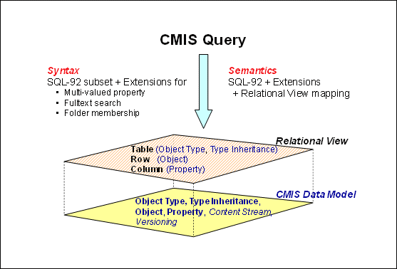

5 Referências
Seguem abaixo as principais referências consideradas para o desenvolvimento CMIS CM8 com OpenCMIS:

Apache Chemistry openCMIS
http://chemistry.apache.org/java/opencmis.html

OASIS - Content Management Interoperability Services (CMIS) Version 1.0
http://docs.oasis-open.org/cmis/CMIS/v1.0/os/cmis-spec-v1.0.html#_Toc243905422

OASIS Content Management Interoperability Services (CMIS) TC
http://www.oasis-open.org/committees/tc_home.php?wg_abbrev=cmis

IBM CMIS for Content Manager V1.0 Release Notes
http://publib.boulder.ibm.com/infocenter/cmgmt/v8r4m0/index.jsp?topic=%2Fcom.ibm.cmcmisreadme.doc%2Fcmisv1relnotes.htm

IBM CMIS for Content Manager, Version 1.0.+
Programming IBM CMIS for Content Manager applications
http://publib.boulder.ibm.com/infocenter/cmgmt/v8r4m0/index.jsp?topic=%2Fcom.ibm.installingcmcmis.doc%2Fcmsdv000.htm

IBM ECM Services Technology Preview for OASIS CMIS
http://www.ibm.com/developerworks/forums/forum.jspa?forumID=1839

IBM CMIS for Content Manager Version 1.0 publication library
http://www-01.ibm.com/support/docview.wss?uid=swg27020481

IBM SoftwareEnterprise Content Management
Content Management Interoperability Services (CMIS)
http://www-01.ibm.com/software/data/content-management/cm-interoperablity-services.html

Hardware and software requirements for IBM CMIS for Content Manager Version 1.0
http://www-01.ibm.com/support/docview.wss?uid=swg27020412

Content Management Interoperability Services
http://en.wikipedia.org/wiki/Content_Management_Interoperability_Services

